1. **Entity Relationship Diagram**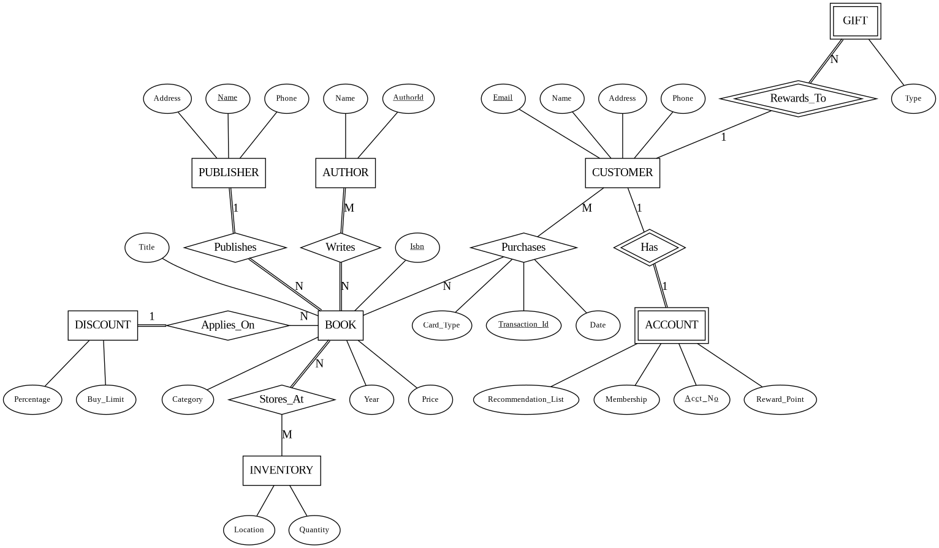
2. **Relational Database Schema**

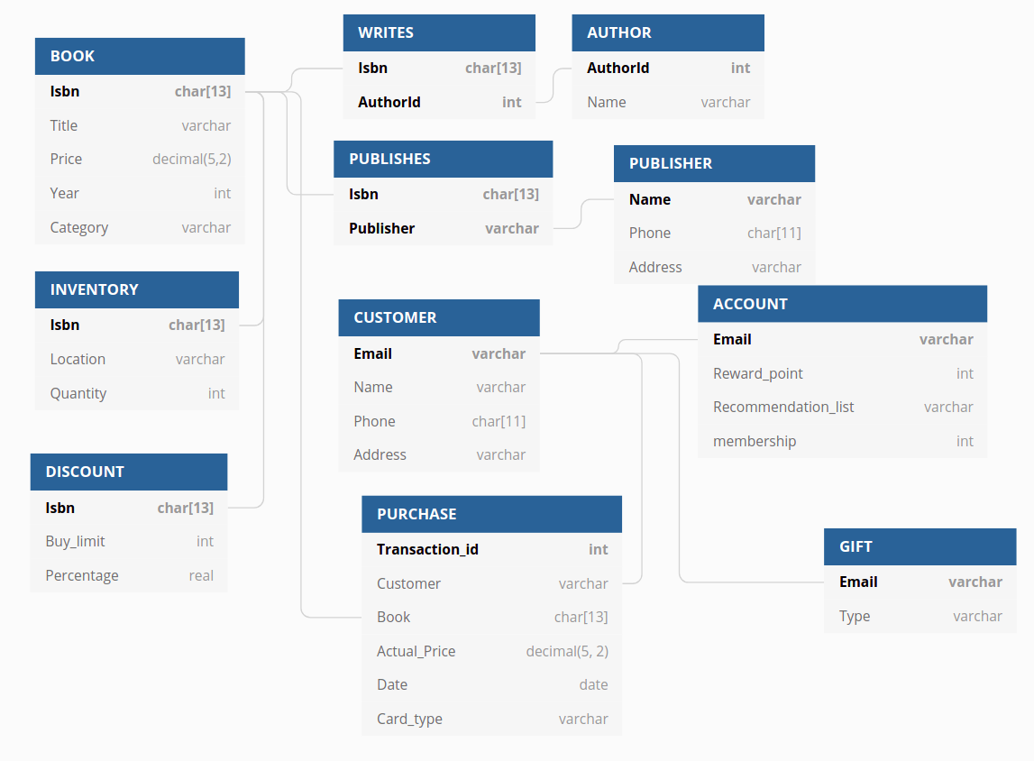

1. **Level of Normalization for Each Table**

Book: BCNF

Publisher: BCNF

Author: BCNF

Customer: BCNF

Account: BCNF

Purchases: BCNF

Publishes: BCNF

Writes: BCNF

1. **A description of each of the indexes that you have chosen to implement on your database, along with rationale for each.**
2. **Views**
3. Description:

This view is able to show all the titles and their dates of purchase made by each customer. And this could be useful to make book recommendations for a customer by looking at his or her purchase history.

Relational algebra expression to produce this view:

SQL statements to produce the view:

CREATE VIEW CUSTOMER_P

AS SELECT B.Title, P.Date

FROM BOOK AS B, PURCHASE AS P, C AS CUSTOMER

WHERE B.Isbn = P.Book

5-10 sample outputs:

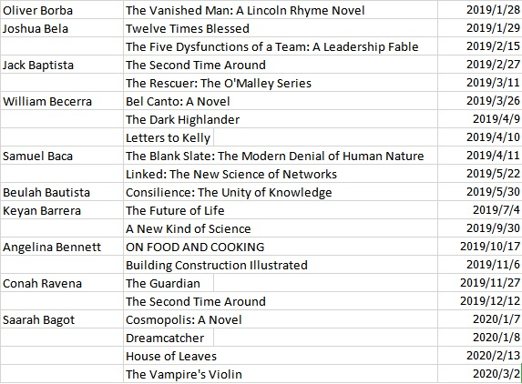

1. Description:

This view is able to show the total number of books purchased by each customer. And this could be useful to see if this customer deserves a gift by making a certain amount of purchases in this store.

Relational algebra expression to produce this view:

SQL statements to produce the view:

CREATE VIEW CUSTOMER_N

AS SELECT P.Customer, COUNT(Book)

FROM PURCHASE AS P, CUSTOMER AS C

5-10 sample outputs:

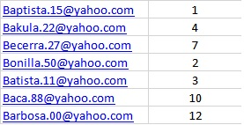

6. **A professionally presented description of three sample transactions useful for your database. This should include the sample SQL code for each transaction as well as an English language description of what “unit of work” the transaction represents. Remember – a transaction is a sequence of SQL statements taken as a unit – this can be reads and writes together or just a sequence of writes. One example of a sample transaction you might want to consider is the user making changes to an order – what might need to be considered a transaction in that case?**